**Modelling the shocks of Brexit on UK and its major trading partners by G-Cubed Model**

***Chi-Sheng Lo***

**U5744457**

**Australian National University**

**Abstract**

This paper examines exchange rate and labour productivity shocks of Brexit on UK and its major trading partners under two scenarios by using the G-Cubed model. The simulation of model suggests that UK economy will not be pessimistic if there is strong enough productivity growth after Brexit. Germany will reap the benefit from Brexit but only in the short run. As Brexit starts, jump in import price will cause high inflation in UK. Moreover, real GDP could decline due to capital outflow and loss of confidence to invest in UK. However, sharp depreciation in GBP will propel the competitiveness of UK export. In the mid-long run, lower wage will gradually induce improvement in labour demand. The pace of consumption and domestic production recovery will then depend on the degree of labour productivity growth. For policy implication, UK needs to renegotiate robust trade deals and remains open to attract global talents to reduce uncertainty that has direct positive impact on risk premia and negative impact on investment.

**JEL Classifications:** C50, D58, F01

**Keywords**: Brexit, Exchange Rate Shock, Labor Productivity Shock, G-Cubed Model

**I. INTRODUCTION**

On 23rd June, 2016, referendum in the United Kingdom (UK) showed that the majority was in favour of Brexit which became a shock to the global financial markets because the realized result was far from the poll which was in favour of Brexit. Political uncertainty usually causes surges in financial market volatility and risk premia that lead to decline in investment. Immediately following the shock, there were extremely high volatilities across global financial markets in the first two days. S&P VIX, which represents the benchmark for fear factor, jumped 40 percent from 17.25 to 25.76 in just one day.

Leaving the European Union (EU) could be worrisome. Prior to Brexit, UK is part of EU who enjoys free-trade with 53 members. UK will have to renegotiate imposition of tariff and need to re-join World Trade Organization (WTO) as an individual country. Aleisina and Spolaore (1997) found that economic activity is positively influenced by the size of the market (p. 1040) and concluded that smaller countries require economic integration. (p. 1042).

To reduce uncertainty, in August 2016, the Bank of England (BOE) announced several monetary stimulus actions include 25 basis point cut in bank rate to 0.25 percent, a purchase of $10 billion pound of UK corporate bond, and $60 billion pound of bond. Moreover, UK’s chief of treasury announced that he will consider fiscal stimulus to boost UK economy. UK has been running fiscal deficit since 2002. The latest figure is at 4.4 percent of GDP but is in declining trend since 2009 when UK tried to recover the aftermath of Lehman Brothers crisis. Therefore, to ease Brexit risk, it is likely that UK’s fiscal deficit will increase again in coming years.

Across the English Channel, the European Central Bank (ECB) in 22nd July, 2016 had announced that it might increase the current package of Quantitative Easing (QE) of $80 billion Euro asset purchase per month if Brexit worsens Europe. However, Germany’s Bundesbank claimed that ECB is already very expansionary and opposed further increase in stimulus. Moreover, the US Fed has continued to delay interest rate lift after Brexit vote. Bank of Japan had announced a further expansion of stimulus because of Brexit. Canada and China had also announced that they will take necessary action in the future.

Even long before the breakout of Brexit, Pain and Young (2004) already discussed the consequence of Brexit and estimated a permanent 2.25 percent reduction in output but argued that impact on employment will be relatively small to output because as wage falls, firms will, in fact, be more attracted to increase hiring in spite of lower aggregate demand (p. 406). Some argue that leaving EU is likely to reduce bilateral trade between each other. Glick and Rose (2002) found that when both countries left a currency union, they will experience a near halving of bilateral trade (p. 1138). Ebell and Warren (2016) predict that by 2030, UK GDP will reduced by as much as 3.7 percent under WTO scenario in which there will be no membership in free trade agreements with EU and the long-run deterioration of term of trade will lead to decline in wage by as much as 6.3 percent (p. 136). Fichtner, et al (2016) argued that Brexit not only will reduce economic growth in the UK itself, but also leads to a reduction in export opportunities for the euro area and Germany (p. 306). Fichtner, et al (2016) used National Institute Global Econometric Model (NiGEM) and concluded that UK’s investment will fall substantially and Germany’s demand for capital goods will decline (p. 362). Kierzenkowski, et al (2016) maintained that UK economy would be hit by tighter financial conditions, weaker confidence, higher trade barriers, and higher restrictions on labour mobility (p. 5). Bouoiyour and Selmi (2016) argued that Brexit is harmful for both UK and EU because of falling trade flows and capital outflows (p. 19).

As country risk elevates, UK’s credit will be downgraded. Gande and Parsley (2005) pointed out that negative credit rating will significantly increase sovereign bond spread (p. 717). Almeida, et al (2016) stressed that sovereign debt impairments can affect financial markets and real economic activity through a credit ratings channel (p. 33). Pastor and Veronesi (2013) analysed the political uncertainty on stock price and found that stock volatility and risk premium induced by political uncertainty will be larger especially during bearish market (p.543). Kelly, et al (2016) found that equity risk premium contains a jump component (p. 2468). Mckibbin and Stoeckel (2009) concluded that a sharp rise in equity risk premium will lead to fall in private investment, increase in cost of capital, and collapse in demand for durable goods (p. 587). Baum, et al (2004) stated that exchange rate volatility has significant impact on real exports (p. 18). Dellariccia (1999) found that among Western European countries, there is clear evidence of significant negative effect of exchange rate volatility on bilateral trade (p. 331). Bloom (2009) researched the impact of equity return volatility shock using the Vector Auto Regression (VAR) and found that large macro uncertainty shock will produce rapid and rebound in in output, employment, and productivity growth (p. 674).

**II. THE MODEL**

This paper uses the G-Cubed multi-country model to analyse the impact of Brexit on UK and its major trading partners across Continental Europe, North America, and Asia. G-Cubed is a large-scale computable macro-econometric model and a branch of Dynamic Stochastic General Equilibrium (DSGE) models. Unlike standard DSGE, G-Cubed includes sectoral and country disaggregations. G-Cubed connects the transition between short-run and long-run economy by incorporating intertemporal optimization of investment and savings and intertemporal optimization by agents such as consumers and firms. McKibbin and Vines (2000) proved that G-Cubed has been insightful in analysing major historical events including Reagonomics on Europe, German reunification, impact of NAFTA, the Asian crisis, and the US equity market since 1980s and in explaining six major puzzles in international macroeconomics (p. 112).

G-Cubed is convenient to forecast the world economy in the long run and to model bilateral international trade. Besides assigning exogenous shocks, user can manipulate the degree of exogenous shocks to compare the differences in impacts on endogenous variables. Furthermore, unlike time series model like VAR that is backward-looking and fails to explain nominal rigidity, G-Cubed is forward-looking with rational expectation in which all equations are derived from optimization given liquidity and budget constraints. Thus, G-Cubed does not fall into the trap of Lucas critique which criticized for only making forecast from the historical data and disregarding rational expectation in micro framework. Moreover, G-Cubed takes short run nominal wage rigidity into account to allow a long period of unemployment. Short-run behaviour will be the weighted average of optimization. Most distinctively, G-Cubed sets the distinction between physical and financial capital in which the former is characterized by the stickiness and the later can be explained by mobile and international capital flow that always go for assets with the highest expected return.

Yet, G-Cubed is not a perfect black box fortune teller. It still has limitation like other macro-econometric models. In reality, the world is complex and fast changing. There will always be new kinds of uncertainties coming up. G-Cubed will still require frequent update in assumption of exogenous shocks manually to run the most up to date event analysis.

**III. SCENARIOS**

I will compare results from two scenarios using exchange rate and labour productivity shocks. Exchange rate shock means that there is depreciation in home currency while a productivity shock means that there is negative growth in labour productivity. Both scenarios set baseline values in 2015. The forecasting horizon will be from 2016 to 2040.

Scenario I assumes that there is higher risk in the UK and the non-German Eurozone countries and a fall in service sector productivity in the UK capturing the decline of the finance sector in the City of London. There will be 2 percent increase in exchange rate shock for UK, 1 percent increase in exchange rate shock for the Rest of Euro zone (EUZ), and negative phase-in shock of labour productivity which implements reductions by 1 percent in 2016, 2 percent in 2017, 3 percent in 2018, and 4 percent from 2019 forever for service sector in UK.

Scenario II assumes that there is same country risk shocks as scenario I, but assumes that UK will experience improved productivities in energy, mining, agriculture, durable and nondurable manufacturing, and service sectors over time. So there will still be 2 percent increase in exchange rate shock for UK, 1 percent increase in exchange rate shock for EUZ, but positive phase-in shock of labour productivities which implements additions by 0.5 percent in 2017, 1 percent in 2018, 1.5 percent in 2019, 2 percent in 2020, 2.5 percent in 2021, 3 percent in 2022, and 3.5 percent from 2023 forever for the aforementioned sectors in UK.

**IV. DATA**

UK’s top 15 ranked trading partners are: Germany, US, China, Netherlands, France, Belgium, Ireland, Switzerland, Italy, Spain, Norway, Canada, Poland, Sweden, Japan. Therefore, in this research project, I will pick macro data of German, US, China, Canada, Japan, Rest of OECD (OEC) that covers Switzerland, Norway, and Sweden, and EUZ that covers Netherlands, Italy, France, Spain, Belgium, and Ireland, to compare with that of UK. The variables I will be comparing are real GDP, consumption, total capital goods demanded, aggregate output, labour demand, total stock market value, real exchange rate, household price of imports, trade balance, inflation, wage rate, total government spending, 10-year real interest rate, and policy interest rate.

In sections V and VI, my analysis will include UK, Germany, US, China, EUZ, OEC, Canada under each scenario. In section VII, I will compare scenarios I and II for UK only. From section VIII to X, my analysis will include UK and its top four trading partners: Germany, US, China and EUZ under both scenarios.

**V. RESULTS OF SCENARIO I**

Following the unexpected and exogenous Brexit shocks of scenario I, UK’s real GDP will decrease 4.93 percent in 2018 versus the baseline, and then gradually converge upward toward baseline but still 1.15 percent below baseline by 2040. EUZ also has similar trend but slightly less severe except for 2016 when its GDP drops the most among all trading partners with UK. Other trading partners will continue to grow with diminishing return. Germany will be the most beneficial from Brexit shocks in the first 14 years. By end of 2016, consumptions in UK and EUZ will decline about 6.07 percent and 4.83 percent, respectively. Others will have consumptions increased slightly with Germany taking the lead. Total capital goods demanded in EUZ and UK will take big hits by 34.66 percent and 34.55 percent. On the other hand, Germany’s aggregate demand will be boosted by more than 13 percent. Canada will have second highest aggregate demand growth early on. Wage rate in UK will actually increase in the early stage of Brexit but will fall below baseline from 2022 to 2034. Surprisingly, wage rate in EUZ will dive sharply by 4.07 percent in 2020. Labour demand in UK is expected to fall since 2017 and then gradually return to baseline by 2023. Employment in EUZ will drop the most among all trading partners with UK. Once Brexit starts, most European who originally work in UK will not be eligible to stay and there will be a period of job market friction when they return to continental Europe.

Aggregate outputs of UK and EUZ will fall severely in 2017 by 3.77 percent and 2.79 percent while Germany’s aggregate output will increase 2.59 percent. Other countries’ aggregate output changes are relatively flat. The total stock market values in UK and EUZ will drop 8.6 percent and 10.6 percent, respectively, while Germany, whose total stock market value will increase 4.9 percent in 2016, will take the advantage of Brexit. UK currency will depreciate the most compare to other trading partners and the bottom is in 2016 which will fall by 11.87 percent. The main reason is that most people will lose fate about UK economy and its currency, so they will run away from GDP denominated securities. Plakandaras, et al (2016) has also concluded that GBP depreciation is based on the uncertainty caused by the Brexit (p. 14). However, in the long run, UK’s real exchange rate will bottom out in 2016 and converge toward above baseline by 2038. While trade balances in other trading partners will retreat all slightly, trade balances in UK and EUZ will jump 6.79 percent and 4.76 percent, respectively in 2017 because of depreciations in GBP and Euro will boost the exports and lead to trade balance surplus. However, trade balance surplus in UK also means that UK has to sell their goods at much lower price. While EUZ will have significant deflation, UK’s growth in CPI will jump the most among other trading partners, followed by Germany because of jump in import prices in 2016. The dispersion between UK and its major trading partners in import price growth will be huge. For example, by 2017, import prices in UK and Germany are expected to increase 6.8 percent and 1.9 percent, respectively, while others will all have import prices decreased. Then after four years of consecutive inflation in UK, BOE will then raise the policy rate to ease inflation.

Hassan (2013) concludes that expansion of currency beyond borders will lower real and nominal interest rates because bonds issued in the currencies of economies that account for a larger share of world wealth are a better hedge against consumption risk. (p.2307). Therefore, from opposite point of view, it is highly possible that UK will experience rate hike after Brexit. UK’s 10-year real interest rate hike will be among the largest permanently from 2016 to 2040 since UK’s treasury bond is no longer attractive to major institutional investors who need to park capital in a safe haven like the US treasury bond. Policy interest rate in EUZ and UK will rise by 71 and 66 basis points, respectively, in 2017 after both European Central Bank and Bank of England implement contractionary monetary policies to combat inflation.

**VI. RESULTS OF SCENARIO II**

Following the unexpected and exogenous Brexit shocks of scenario II, UK’s real GDP will fall by more than three percent immediately but then gradually reverse to above baseline by 2023. Germany will be the leader until 2025; after that, UK will turn out to be the leader. By end of 2016, both UK and EUZ will lead the slumps in consumption which drops by 6.45 percent and 4.87 percent, respectively. On the contrary, Germany and Canada will take the lead in consumption growth. In 2017, the total capital goods demanded of UK and EUZ will slump substantially by 39.64 percent and 36.07 percent, respectively. In contrast, the aggregate demand of Germany will jump 16.28 percent. In labour market, EUZ will suffer the most from pullback in employment, followed by UK which dropped by 2.56 percent in 2017. Germany will lead labour demand from 2016 to 2019. By 2020, UK’s wage rate will start falling and EUZ’s wage rate will dip among the most ever since 2017. Conversely, Germany will have the most robust wage growth. Furthermore, UK’s aggregate output will stay in downtrend compare to baseline until 2021 as labour productivity eventually picks up to pre-Brexit era. EUZ’s aggregate output will be even worse than UK under scenario II. In addition, EUZ’s total stock market value will be severely hit by ten percent retreat and UK will only suffer half of EUZ’s loss in 2016. As a result, Germany’s equity market will take the best advantage of Brexit in the first two years.

As investors are running away from GBP denominated assets, UK’s currency will depreciate the most, followed by EUZ’s currency. For instance, in 2017 and 2018, GBP will depreciate by 9.5 percent and 8.9 percent, respectively. On the contrary, Germany and other trading partners including US, Canada, Japan, China, Germany, and OEC countries will have their currencies appreciated slightly. While Germany’s trade balance will drop the most among all trading partners, UK and EUZ’s trade balance will increase 6.15 percent and 4.58 percent, respectively, in 2017 due to sharp depreciation in GBP and EURO. UK’s inflation will jump among the highest , while EUZ will suffer from deflation. Germany’s trade balance will be running in deficit and will have the second highest inflation in the first two years right after Brexit.

UK’s 10-year real interest rate will be among the highest permanently from 2016 to 2040. In contrast, interest rates in Germany, US, China, OEC, Canada, and Japan will be slightly below baseline until 2040. Policy interest rates in EUZ and UK will rise by 64 and 51 basis points, respectively, in 2017. Import prices in UK and Germany will both increase but the growth rate in UK will be 3.9 times that in Germany in 2016. As UK inflation rises for two consecutive years, BOE will raise policy rate to ease the price hike. From 2019 onward, UK will have highest policy rate among all of its trading partners. Similar to the trend in 10-year real interest rate, policy interest rates in Germany, US, China, OEC, Canada, and Japan will be slightly below baseline until 2040.

**VII. COMPARISON FOR UK ONLY**

UK’s real GDP under scenario I is much worse than that under scenario II. Real GDP under scenario I will stay below baseline until 2040 but real GDP under scenario II will shift above baseline by 2023. Employment under scenario I is higher than that under scenario II during the first year of Brexit and then become worse off from 2017 to 2027 as higher wage rate under scenario I will be less attractive to employer than scenario II. In theory, higher labour productivity in scenario II will have lower marginal product of productivity which equals to wage. In financial markets, total stock market value under both scenarios will fall but scenario I will cause damage twice as large as scenario II in 2017. Real exchange rates under both scenarios will depreciate with similar magnitude in the first three years of Brexit, but since 2018, real exchange rate under scenario I will pick up much faster than that under scenario II. Trade balances under both scenarios will increase with identical magnitude but trade balance under scenario I is significantly better from 2016 to 2024 due to deeper depreciation in GBP. CPI under scenario I is slightly higher and both scenarios will inflate in the first two years after Brexit. However, CPIs under scenarios I and II will return to baseline in 2019 and 2018, respectively. 10-year real interest rate under both scenarios will increase but 10-year real interest rate under scenario II is significantly higher from 2016 to 2020. Policy interest rate under both scenarios will rise but significantly higher under scenario I from 2016 to 2020. For example, policy interest rate under scenario I will be 20 basis points higher in 2017. However, from 2021 to 2031, policy interest rate under scenario I will be slightly lower than that under scenario II as deflation begins.

**VIII. UK VERSUS TOP FOUR TRADING PARTNERS**

This section will compare UK with its top four trading partners: Germany, US, China, and EUZ. In the short run, real GDP of Germany will get the greatest benefit under scenario II. EUZ will have sharpest decline UK will be the second worst in real GDP growth under scenario I. UK’s trade balance growth under scenario I will beat all major trading partners due to sharp GBP depreciation while Germany under scenario I will have the largest decline in trade balance. In employment, Germany will the highest labour demand and maintain highest wage most of the time under scenario I. Conversely, EUZ will have highest retreat in labour demand in the first four years and largest drop in wage rate under scenario I. In policy interest rate, EUZ under scenario I will have the largest rate hike in the first two years while Germany under scenario II will have largest decline in policy rate.

In the long run, UK’s real GDP under scenario II will take the lead significantly as consumption and investment pick up, while the same under scenario I will continue to ranked last. Trade balances of UK under both scenarios will still take the lead but gradually return to baseline while trade balance of Germany will eventually reverse to above the baseline. In employment, Germany under scenario I will have the biggest decline in labour demand from 2020 to 2033. Wage rate of EUZ under scenario I will continue to have largest dip. In policy interest rate, UK under both scenarios will both increase rates and lead others significantly, with scenario II being slightly higher. Germany under both scenarios will have largest declines with nearly identical magnitude.

China will be the least affected by Brexit and will maintain its GDP slightly above baseline most of the time under both scenarios. As UK’s second largest trading partner, US real GDP will have slightly bigger positive reaction than China on Brexit shock in the first four years. Furthermore, US real GDP will be slightly better under scenario I for the first five years.

**IX. SUMMARY FOR UK AND TOP FOUR TRADING PARTNERS**

**UK**

In the short run, contractions in both investment and consumption will outweigh trade balance growth due to sharp depreciation in GBP. However, in the long run, there will be strong reversal in aggregate output under scenario II. Altogether, real GDPs under both scenarios will fall in the short run but eventually the assumption of positive phase-in labour productivity will help UK real GDP turn positive since 2023 while the assumption of negative phase-in labour productivity will make UK real GDP kept at below baseline from 2016 to 2040. Also, surprisingly, in the long run, scenario II will make UK led its top trading partners in real GDP since 2028. In monetary policy under both scenarios, the BOE will raise interest rate to combat sharp increase in inflation caused by surge in import price. Therefore, in the mid-long run, trade balance growth will diminish as GBP bounces back due to interest rate hike after 2016. In fiscal policy under both scenarios, the UK government will boost spending in 2016 but more of it under scenario I. After that, spending will drop and return to steady state.

**Germany**

Germany will reap the benefit from the declines in EUZ and UK and will have highest real GDP growth under either scenario but only in the short-term. Germany’s real GDP growth under both scenarios will peak in 2016 and then converge toward baseline. Consumption remains robust and stable. Total capital goods demanded will jump. Having said that, in monetary policy, Germany will still cut policy rate and the magnitude of rate cut will be more aggressive than other UK’s trading partners. In 2017, Germany is expected to cut policy rate by nearly 35 basis points versus the baseline under both scenarios. The objective of rate cut is to prevent from further domestic currency appreciation that jeopardize Germany’s exports. In fiscal policy, Germany will increase spending in the first two to three years after Brexit.

**US**

Many of UK and US variables will be negatively correlated in the short run. Capital will flow into US for flight to safety. US Fed will likely continue to loosen monetary policy or at least slow down the pace of interest rate hike that has direct effect on overnight interbank rate and treasury yield. The model predicts that US 10-year real interest rate will fall in both scenarios but more so in scenario I. In fiscal policy, US government will increase spending in 2017 and 2018. US GDP will fall below baseline in the first year after Brexit, then bounce back, and fall below baseline again from 2020 to 2040 in scenario II. On the other hand, scenario I will be the mirror image of scenario II in the mid-long run.

**China**

Despite being UK’s third largest trading partner, the impact of Brexit on China’s real GDP will be insignificant. China will lower policy interest rate and keep it below the baseline until 2040. Chinese government has already mentioned that they might implement expansionary monetary policy after Brexit. Another reason is appreciation of RMB after Brexit. More than a quarter of China’s GDP comes from export; therefore, it will be necessary for China to either lower interest rate or execute sterilization to prevent from further appreciation of RMB. In fiscal policy, China is projected to boost government spending by 40 percent in 2030.

**EUZ**

Although shock of exchange rate is only half of that of UK, EUZ will have even steeper decline in real GDP than UK in the first year owing to sharp declines in labour demand, wage, consumption, and total capital goods demanded under both scenarios. EUZ will have the worst labour demand in the first two years under scenario I. Its real GDP will remain below baseline under both scenarios. Due to its currency depreciation, EUZ will have the second best growth in trade balance. However, unlike UK, there will be decrease in import price and deflation. Nevertheless, EUZ will still raise policy rate but only slightly above baseline. Moreover, EUZ will cut government spending by huge margin compare to other trading partners in 2016 and 2017 but will gradually increase the spending to steady state at level slightly above baseline after that.

**X. CONCLUSION**

In this Brexit research using simulation by G-Cubed model, both scenarios assume positive two percent and one percent exchange rate shocks for UK and EUZ, respectively. The difference is that scenario I assumes negative phase-in labour productivity in service sector capturing weakening financial sector in the City of London while scenario II assumes positive phase-in labour productivity of six major sectors in UK. As a result, UK will be in much better position under scenario II. Furthermore, EUZ will be highly correlated with UK. EUZ’s trade balance will go up, but investment, consumption, domestic production, wage, and labour demand will pull back due to high uncertainty. Whenever UK and EUZ are worse off (better off), Germany will be better off (worse off) but by less than half of magnitude of decreased (increased) deviation from baseline in either UK or EUZ. Germany will take the greatest advantage of weakening UK and EUZ economies but only in the short run. Followed by Germany, US will have the second highest real GDP growth. China will be the most indifferent to Brexit both in the short run and long run. Overtime, UK can be more prosperous than Germany, EUZ, US, and China under the assumption of positive phase-in labour productivity in scenario II.

What are the policy implications for Brexit from the simulation of G-Cubed model? There will be negative short-term repercussion for UK’s overall economy owing to heightened country risk that causes loss of confidence and capital outflow. Exchange rate shock is a typical symptom of heightened country risk due to high level of uncertainty that leads to currency slump, inflation hike, surge in equity risk premium, and collapse in asset price. The rise in risk premia is one of the spillover effects caused by rise in cost of capital and country risk that discourage investment because UK will inevitably raise the central bank discount rate to combat inflation. Especially when there is also surprise in pullback of labour productivity of service sector, UK’s overdependence on financial service sector makes its economy even more fragile when many global banks move Europe headquarters away from the City of London. Conversely, UK’s top export industries including automobile, gold, petroleum, turbo-jets, and aircraft parts sectors will be beneficial from sharp depreciation in GBP. In particular, there will be boost in trade surplus with Germany who is UK’s top export partner and represents 15 percent of UK’s export. Nevertheless, household will still likely cutback consumption due to substantial drop in labour demand from finance and banking sector which is UK’s number one industry that accounts for 7.5 percent of UK’s GDP.

Nevertheless, the future for UK’s Brexit is not all that pessimistic. First, although many have concluded that UK will lose bargaining power in trade deals after leaving EU, UK may in fact have more flexibility and even get better trade deals than staying with EU. Second, human capital has always been the strength of UK because of its rich educational resource and openness to talents from around the world. Thus, UK immigration policy should still remain open to attract foreign talents. Third, if UK can keep up its productivity growth in the future, then actual long-term outcome should resemble simulated results of scenario II. Lower real wage, which equals higher labour productivity and lower marginal productivity of labour, will induce gradual increase in labour demand. Supply side will gradually adjusted to match the demand side. Therefore, even though downsizing in banking sector is inevitable, UK’s industry mix will be more diversified and more anti-fragile overtime.

**Exhibit I. Scenario I**

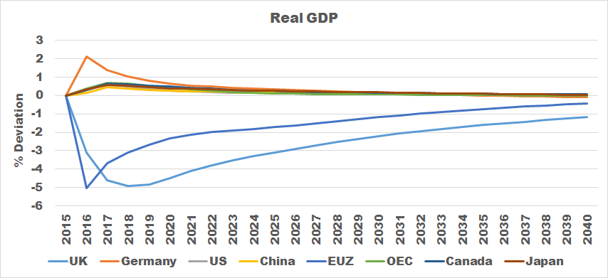

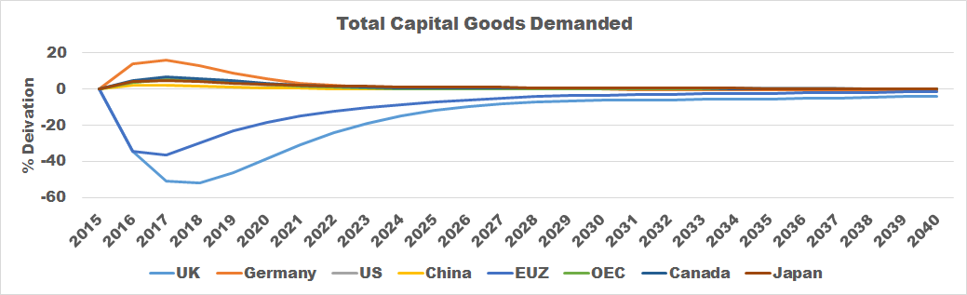

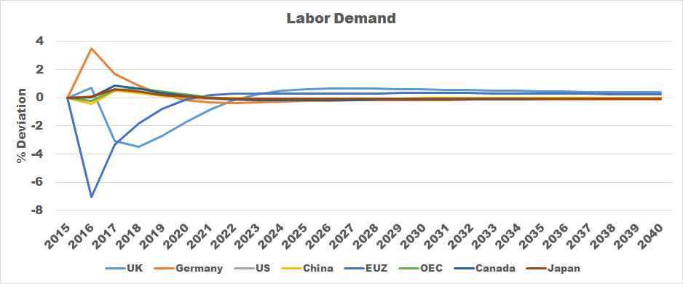

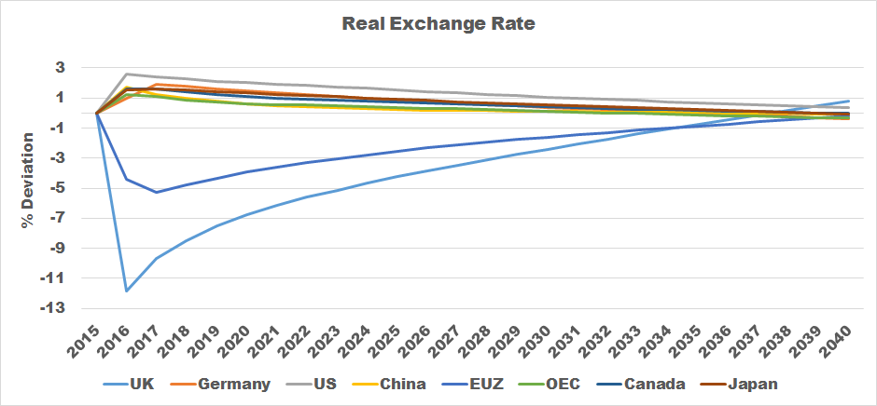

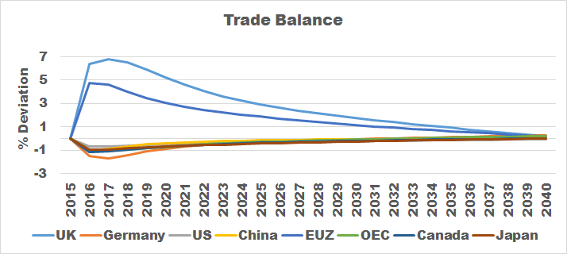

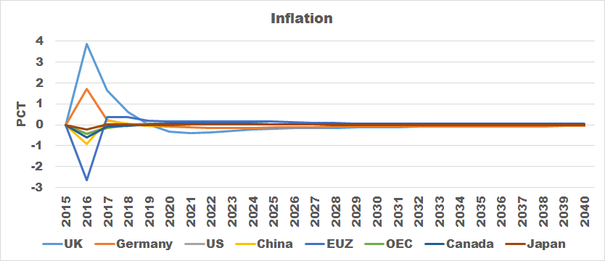

**Exhibit II. Scenario II only**

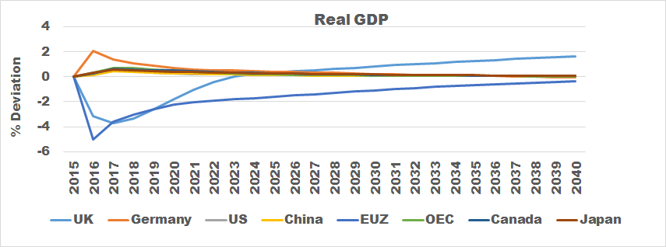

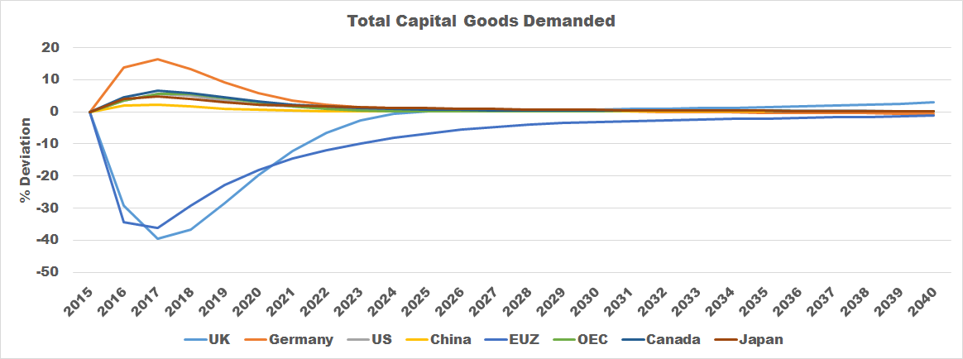

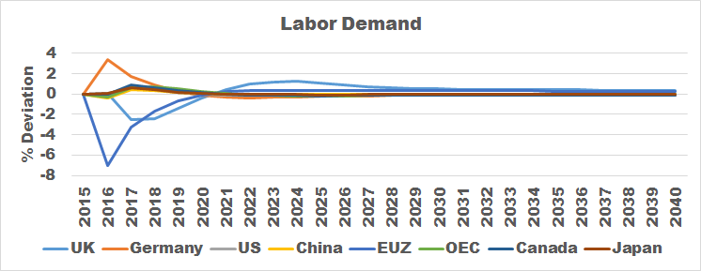

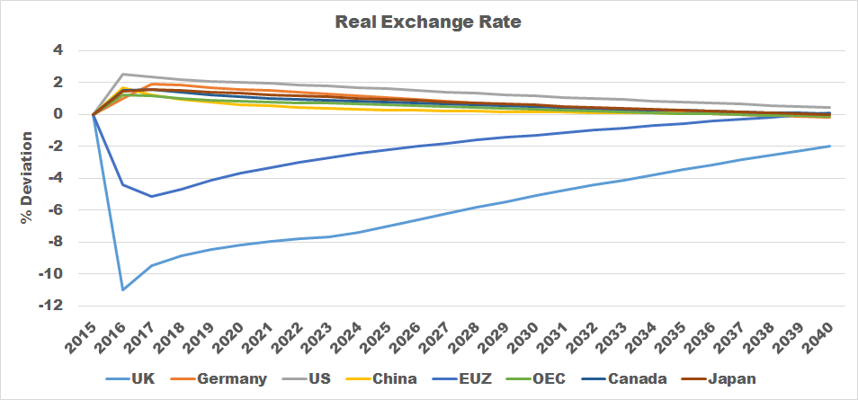



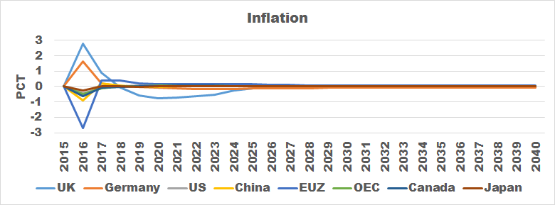

**Exhibit III. Scenario I vs Scenario II for UK only**

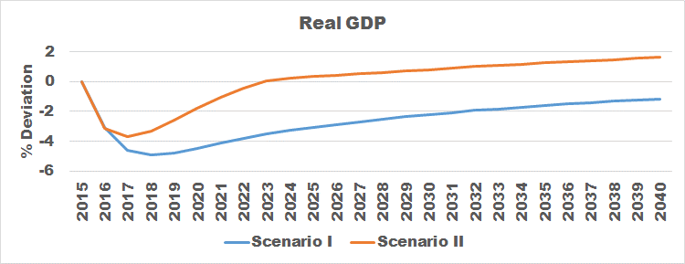

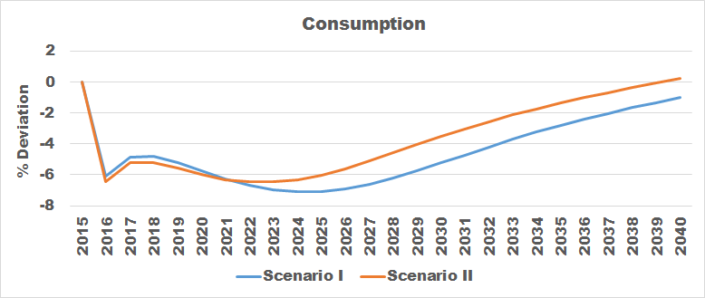



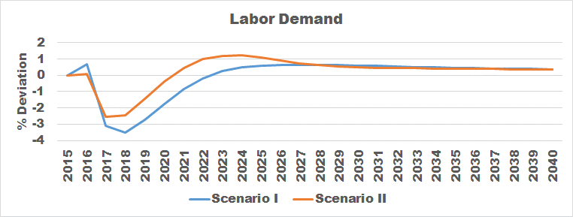

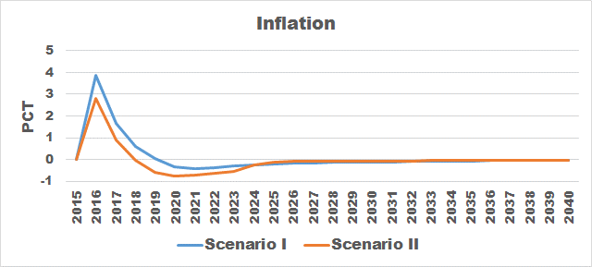

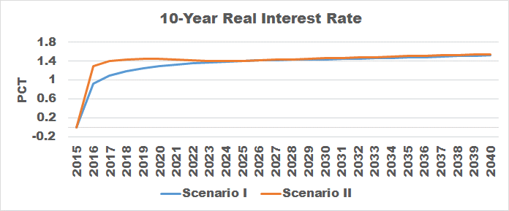

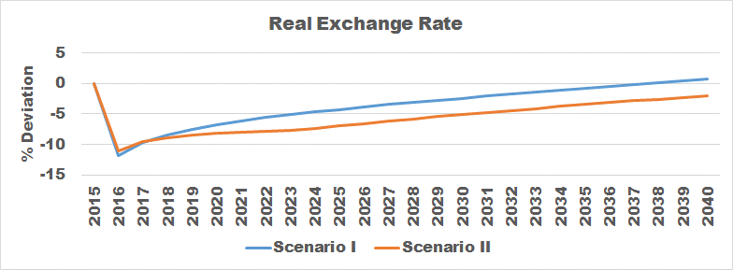

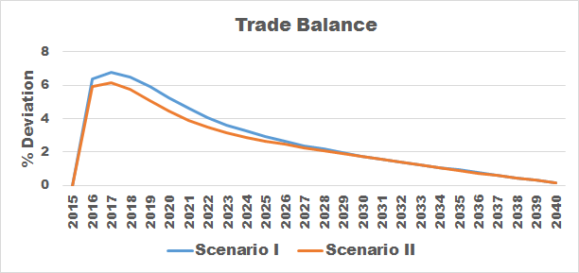

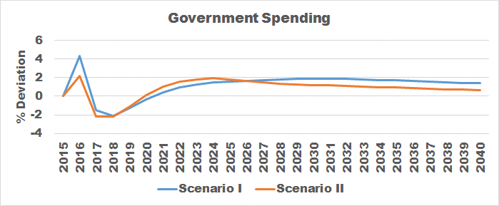

**Exhibit IV. UK vs Top 4 Trading Partners (Scenarios I & II)**

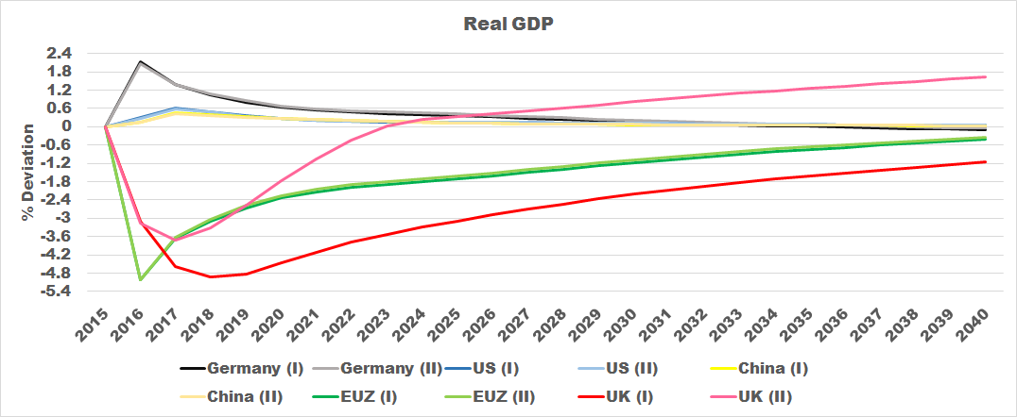

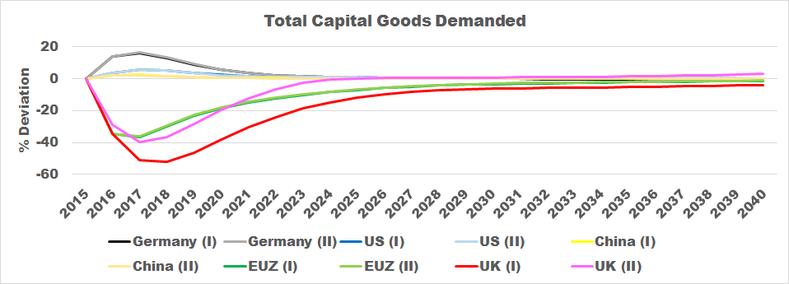

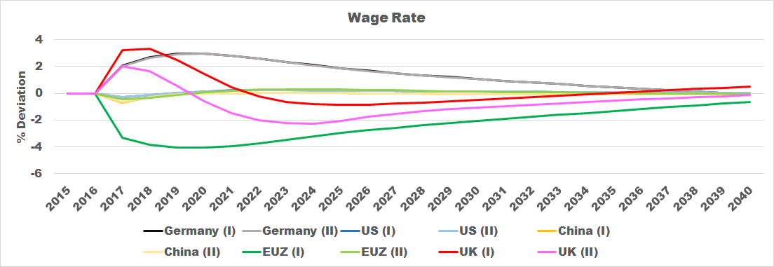

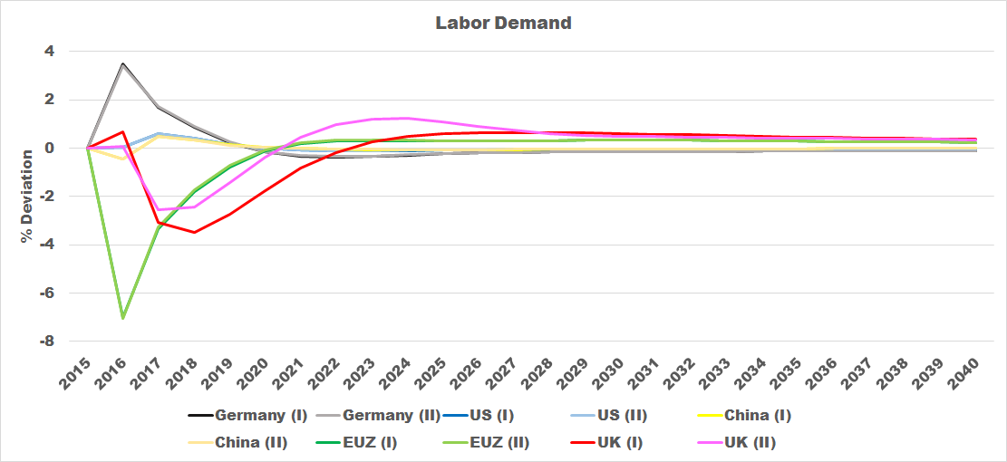

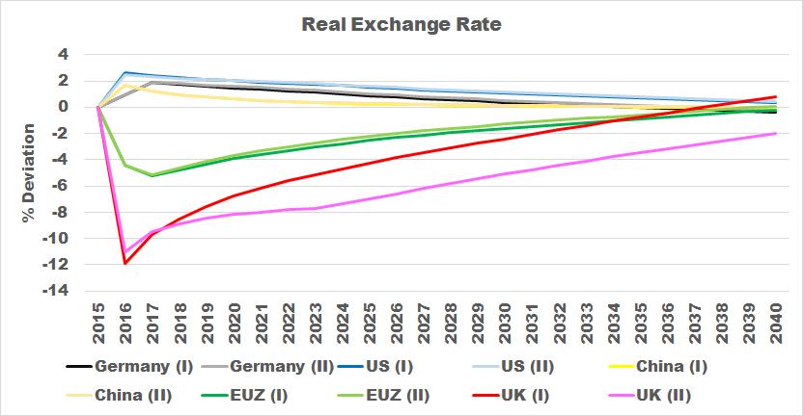

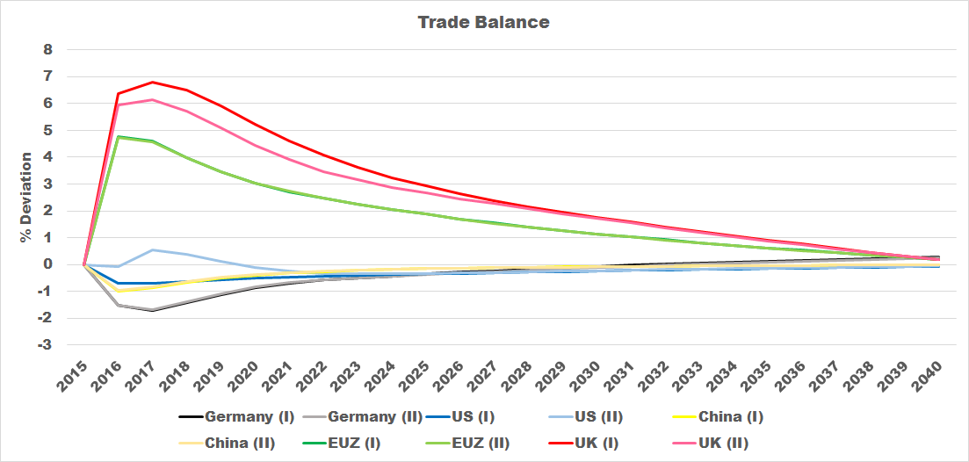

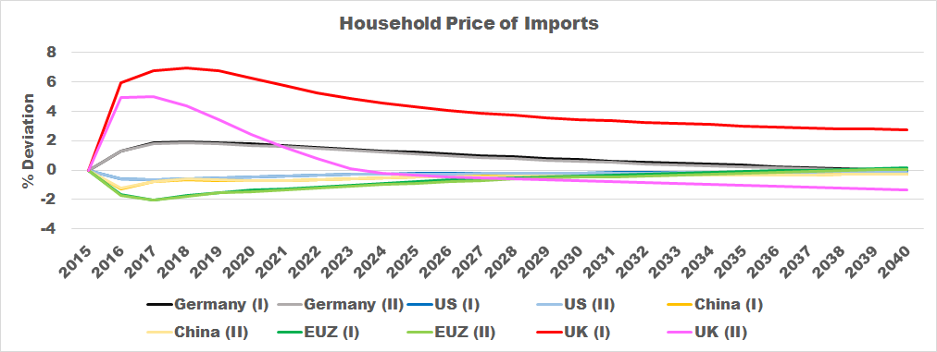

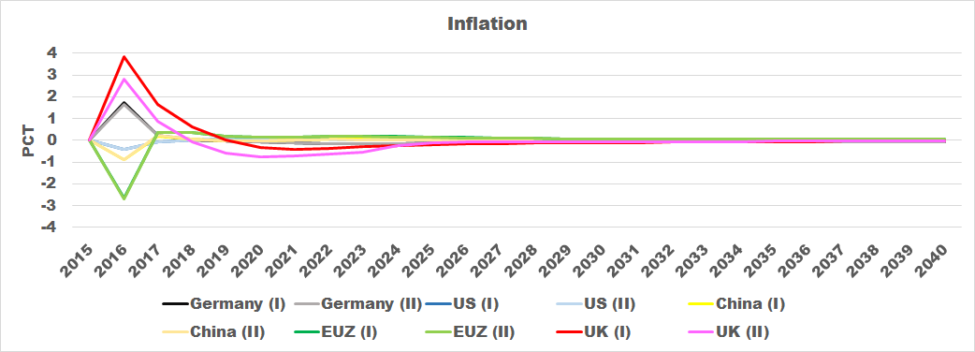

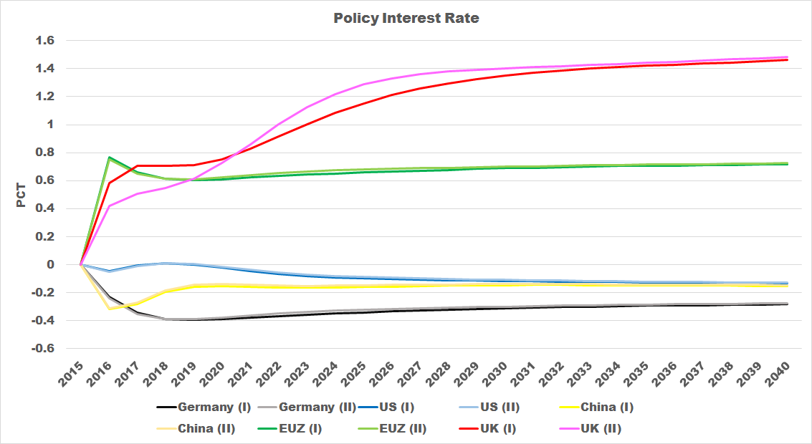

**References**

Alesina, A & Spolaore, E 1997, ‘On the number and size of nations’, *The Quarterly Journal of Economics*, November 1997.

Almeida, H, Cunha, I, Ferreira, MA & Restrepo, F 2016, ‘The real effect of credit ratings: The sovereign ceiling channel’, *Journal of Finance*, 2 June 2016.

Baum, CF, Caglayan, M & Ozkan, N 2004, ‘Nonlinear effects of exchange rate volatility on the volume of bilateral exports’, *Journal of Applied Econometrics*. 19: 1-23 (2004).

Bloom, N 2009, ‘The impact of uncertainty shocks’, *Econometrica*, Vol. 77, No. 3 (May, 2009), 623–685.

Dellariccia, G 1999, ‘Exchange rate fluctuations and trade flows: Evidence from the European Union’, IMF staff papers, Vol. 46, No. 3 (September/December 1999).

Ebell, M & Warren, J 2016, ‘The long-term economic impact of leaving the EU’, National Institute of Economic and Social Research, viewed 30 September 2016,

<<http://ner.sagepub.com/content/236/1/121.short>>.

Fichtner, F, Steffen, CG, Hachula, M, Junker, S, Kirby S, Michelsen, C, Rieth, M, Schlaak, T & Warren, J 2016, ‘Brexit decision puts strain on German economy’, DIW Economic Bulletin 31.2016, viewed 3 October 2016,

< http://www.diw.de/documents/publikationen/73/diw_01.c.540802.de/diw_econ_bull_2016-31-1.pdf >.

Fichtner, F, Steffen, CG, Hachula, M & Schlaak, T 2016 , ‘Brexit decision is likely to reduce growth in the short term’, DIW Economic Bulletin 26+27.2016, viewed 28 September 2016,

<<http://www.diw.de/documents/publikationen/73/diw_01.c.538245.de/diw_econ_bull_2016-26-3.pdf>>.

Gande, A & Parsley, DC 2005, ‘News spillovers in the sovereign debt market’, *Journal of Financial Economics* 75 (2005) 691–734.

Glick, R & Rose, AK 2002, ‘Does a currency union affect trade? The time-series evidence’, *European Economic Review* 46 (2002) 1125 – 1151.

Hassan, T 2013, ‘Country size, currency unions, and international asset returns’, *Journal of Finance*, Volume 68, Issue 6, December 2013.

Kelly, B, Pastor, L & Veronesi, P 2016, ‘The price of political uncertainty: theory and evidence from the options market’, *Journal of Finance*, Volume 71, Issue 5, October 2016.

Kierzenkowski, R, Pain, N, Rusticelli, E & Zwart, S 2016, ‘The economic consequences of Brexit: A taxing decision’, OECD Economic Policy Papers, ISSN 2226583X, viewed 28 September 2016,

<http://www.oecd-ilibrary.org/docserver/download/5jm0lsvdkf6k.pdf?expires=1475155080&id=id&accname=guest&checksum=06301D97DD65A09BF4F0A731780A4504>.

Mckibbin, WJ & Stoeckel, A 2009, ‘Modelling the global financial crisis’, *Oxford Review of Economic Policy*, Volume 25, Number 4, 2009, pp.581–607.

Mckibbin, WJ & Vines, D 2000, ‘Modelling Reality: The need for both intertemporal optimization and stickiness in Models for Policy-making’, *Oxford Review of Economic Policy*, Volume 25, Number 4, 2009, pp.581–607.

Pain, N & Young, G 2004, ‘The macroeconomic impact of UK withdrawal from the EU’, *Economic Modelling* 21 (2004) 387–408.

Pastor, L & Veronesi, P 2013, ‘Political uncertainty and risk premia’, *Journal of Financial Economics*, 110 (2013) 520–545.

Plakandaras, V, Gupta, R & Wohar ME 2016, ‘The depreciation of the Pound Post-Brexit: Could it have been predicted?’, University of Pretoria department of Economics working paper series, viewed 28 September 2016,

<http://www.up.ac.za/media/shared/61/WP/wp_2016_70.zp100026.pdf>.